Hypothesis Testing
H0 = null
HK = alternative

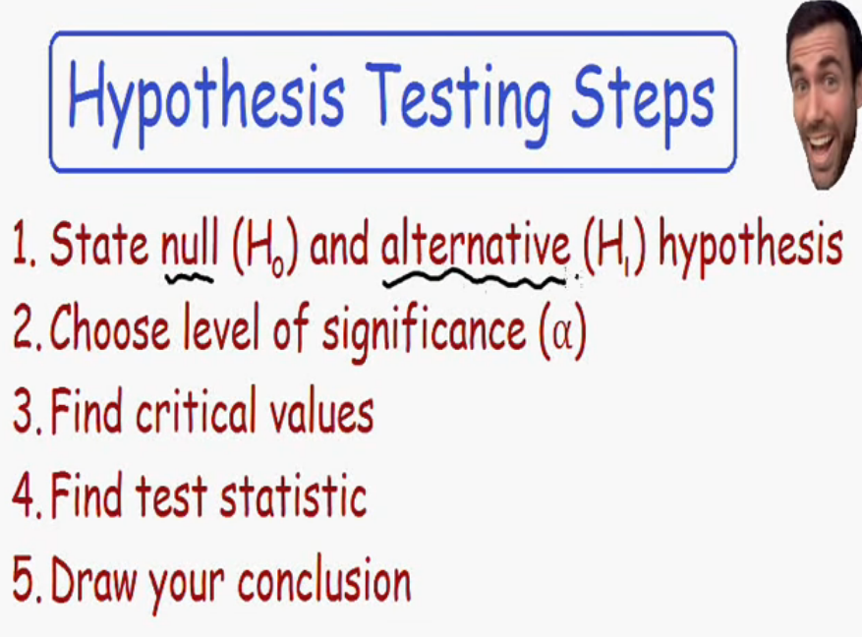

Step 1: when ever alternative test is not equal we have to use two tail test
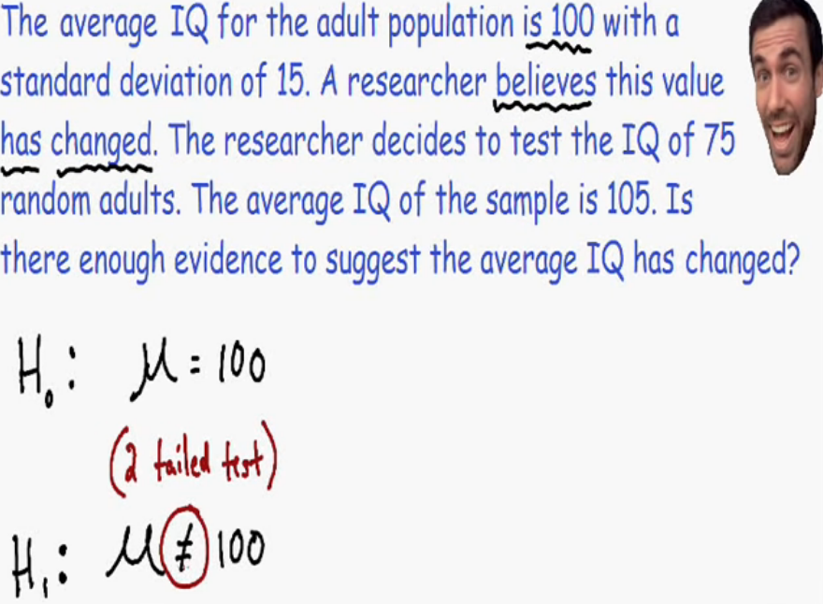
Step2: we need to the significane value.
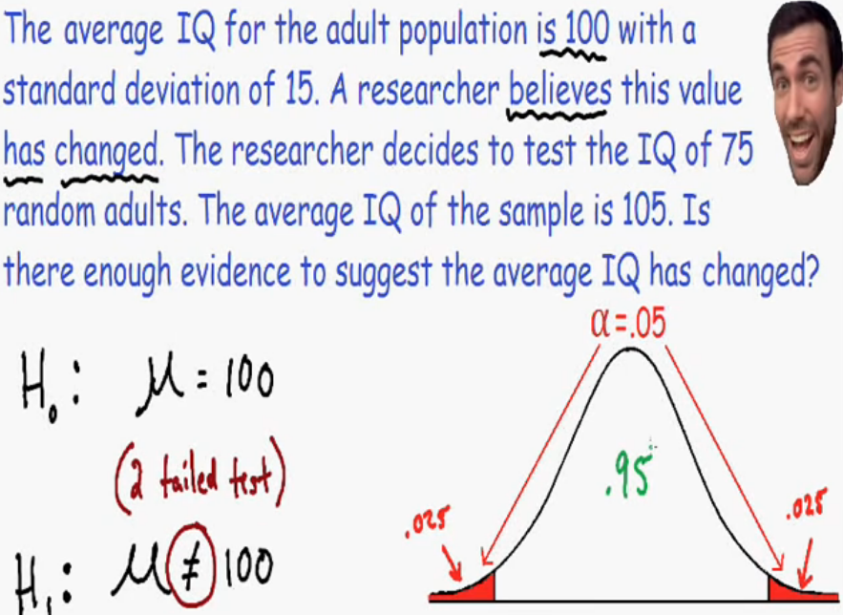

Step3: find the critical values
Critical values may be Z or T
When to use Z? when to use T?
Use Z value if population standard deviation knows….
So in this case the population deviation sigma = 15
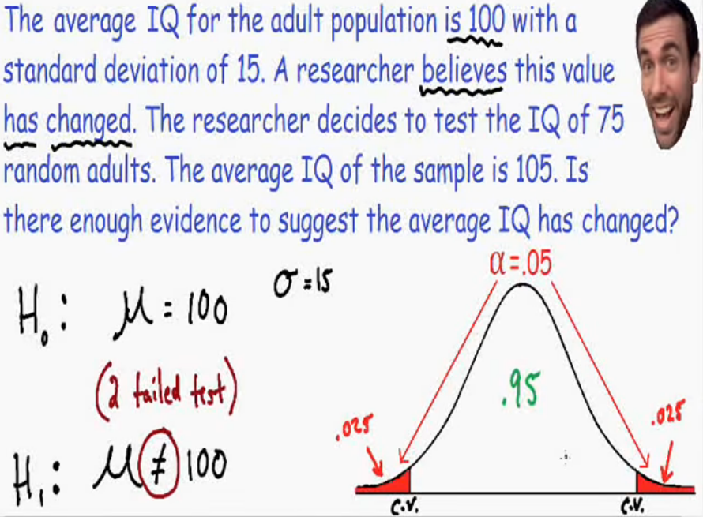
Find the z values for the critical values
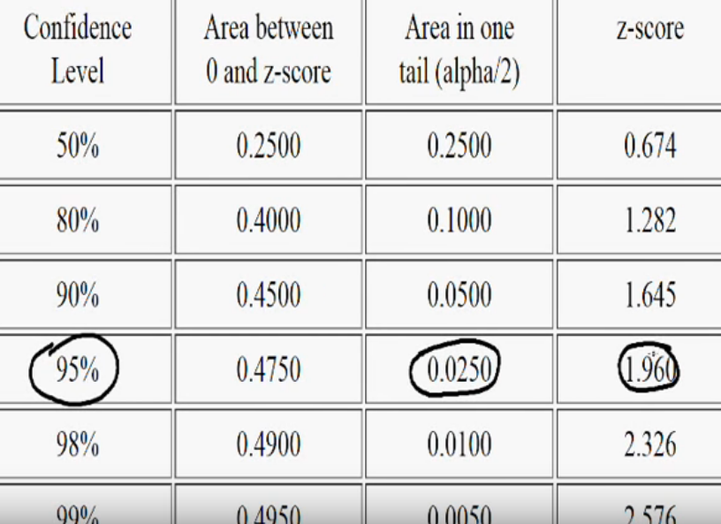
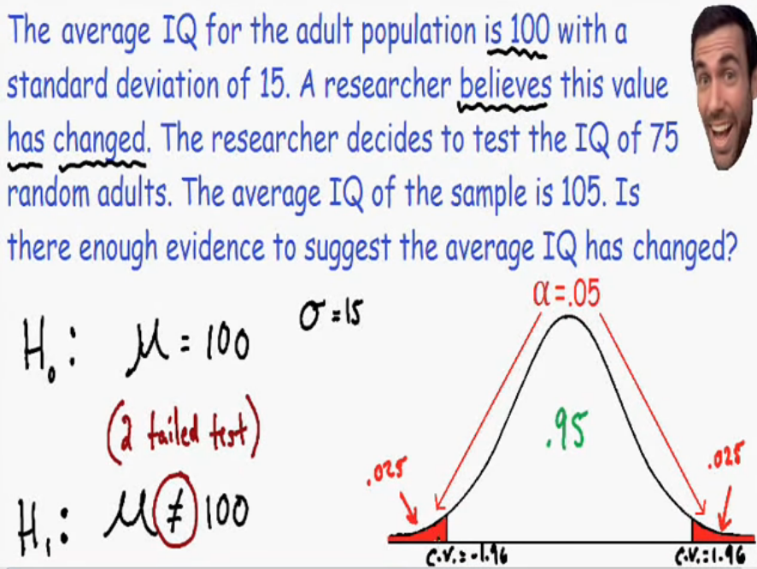
Area under the red is called the rejection region
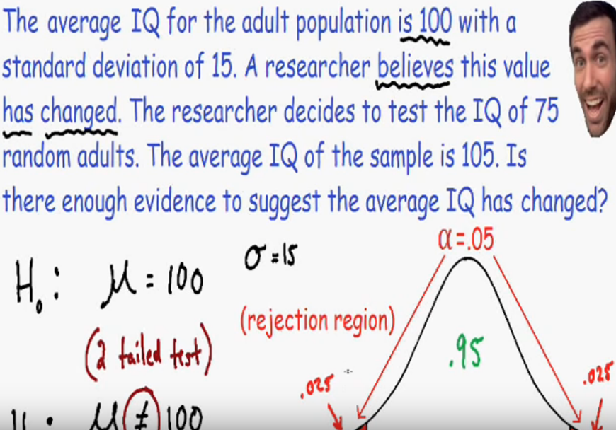
After the test the z score falls in the rejection region we need to reject the null hypothesis
Step 4:
